Bristol Men in Early Years Network Meeting

25/04/2017

Guest Speaker: Dr Simon Brownhill

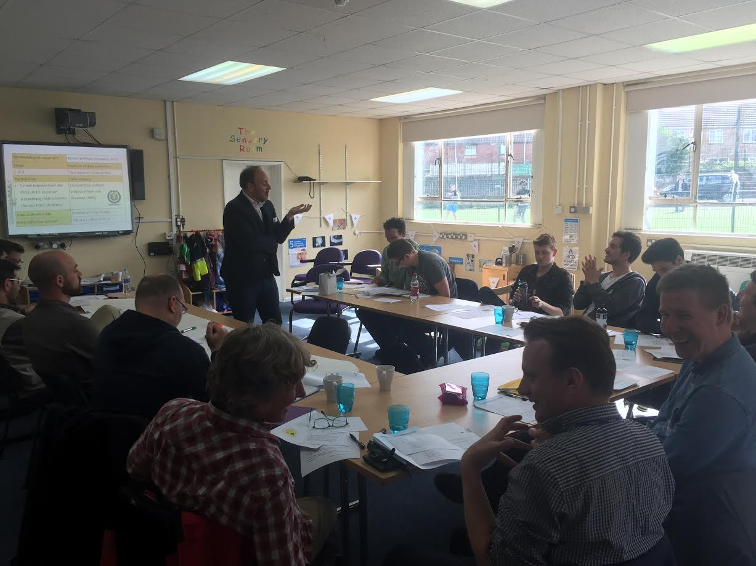

Planned Agenda
Time | Item
2.30 | Welcomes and introductions
2.45 | Dr. Simon Brownhill – ‘Male Role Models’ Revisited’ Simon’s research and experience in the early years is of real value to the network as practitioners respond to the recent suggestion that ‘young boys need to be rescued [by] a new kind of role model’.  This interactive session critically explores the ambiguities of the ‘male role model’ in the early years by drawing on findings from new collaborative research which suggests a “re-imaging” of the label for clarification purposes.
3.45 | Networking tea and coffee break
4.00 | General network updates, CIC status, Best Practice network, Bradford Conference, making respectful men, workforce strategy.
4.15 | Research focus groups and activity
5.00 > | future meeting agendas and any other business

Report/Minutes
Dr Simon Brownhill delivered session ‘Male Role Models Revisited’:
- Quality of practise over the gender of practitioner.
- Practitioners are not considered role models by children. Peers and those with a similar background are more likely.
- The term ‘role model’ is ambiguous, particularly when coupled with the term ‘male’. How is it achieved?
- Call to invert the expression: ‘model of roles’ with the assertion that more context is needed when talking about RMs.

Network Updates
- BMiEY is now a Community Interest Company with its own bank account.
- Discussed Best Practise CPD session on the damaging effects of gender stereotypes.
- Bradford Conference update
- Making Men Respectful talk delivered – Importance of EY promoted alongside the issues of harmful stereotypes.

The meeting ended with providing research data for Dr Simon Brownhill; one group were recorded discussing set questions whilst the other provided written statements to given questions. Some of these will be used for SB’s next book.

Meeting Ends

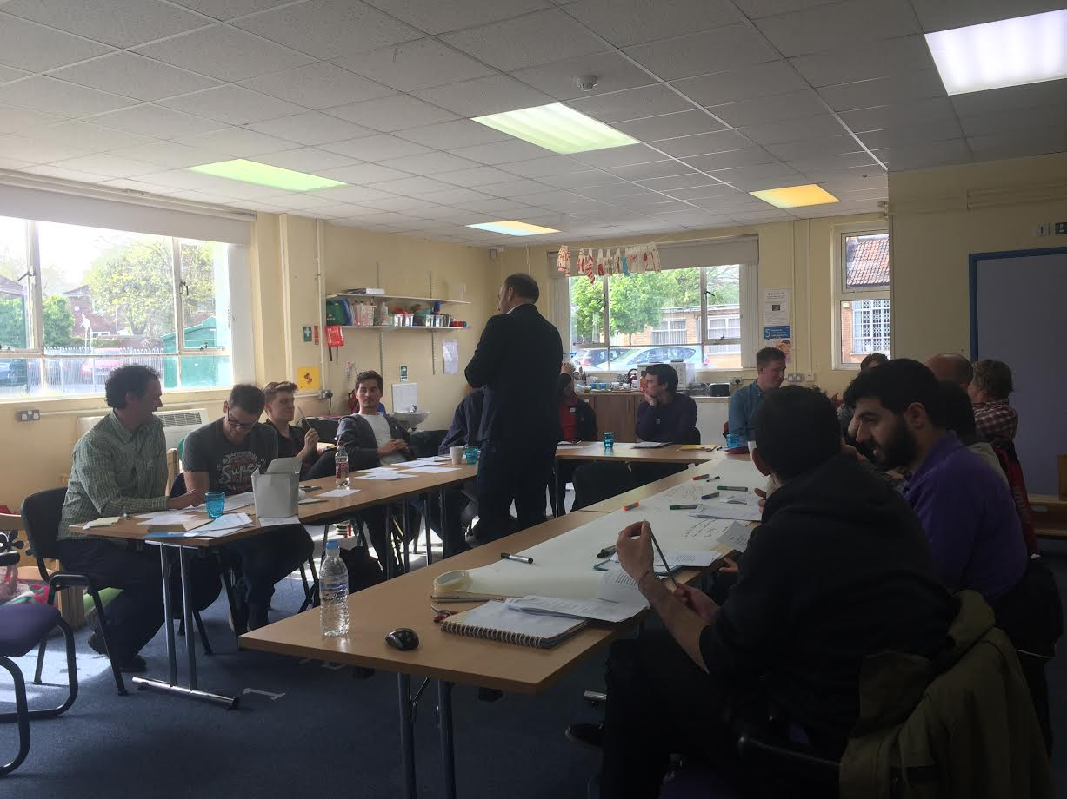

Related Material
DFE: Early Years Workforce Strategy
Section 1.5
https://www.gov.uk/government/uploads/system/uploads/attachment_data/file/596884/Workforce_strategy_02-03-2017.pdf

